**Understanding PRAiS risk model for mortality following heart surgery in children**

**User-testing workshop 4**

**Held on Thursday 10th December 2015 13.00-15.00**

**14a Clerkenwell Green, London, EC1R 0DP**

***Report by Sense About Science***

**1. Introduction**

***1.1 The project***

PRAiS2 is a collaboration between University College London, King’s College London, University of Cambridge, Children’s Heart Federation and Sense About Science and has two primary aims. Firstly, to improve a risk adjustment model for mortality data following children’s heart surgery. Secondly, the data from PRAiS2 will be presented as an online resource for families, the public and the media in order to facilitate appropriate interpretation of this published data. The content of this website will be developed with 8 user-testing workshops over 4 stages. At each stage, the website will be evaluated by 2 user-testing groups: interested users and parents of children with heart disease.

***1.2. User-testing aims***

This second stage user-testing workshop consisted of parents of children who have had heart surgery. Its primary aim was not only to make the risk model plot publicly available but publicly *accessible* and understandable to a wide audience. It aimed to find out what information is (a) vital across the board to interpret the plot accurately, and (b) what is only necessary and useful for those who are going to be delving deeper, e.g. for professional use or parents interested in a particular hospital- so can be less instantly accessible on the website.

***1.3. This report***

This short report captures insights from the participants and presents suggestions for improving communication of the risk model and accessibility of the website to visitors. It also outlines other issues raised during user-testing. General feedback is first outlined, followed by specific feedback relating to each section of the website. Within each section, Sense About Science has made several recommendations based on our extensive experience of public engagement work. The contents of this report include:

1. Introduction

2. Attendees

3. Workshop materials

4. General observations

5. *Intro* tab

6. *Mapped data* tab

7. *Data* tab

8. *Understanding (the data)* tab

9. Final comments

10. Appendices

**2. Attendees**

***2.1. Participants***

* Alison Keen, parent (AK)
* Sinead Mandlik, parent (SM)

***2.2. Observers***

* Christina Pagel, Reader of Operational Research, University College London (CP)
* Emily Blackshaw, Research Worker – DISCOVER Project, King's College London (EB)

***2.3. Facilitators***

* Emily Jesper, Assistant Director, Sense About Science (EJ)
* Joanne Thomas, Projects & Events Officer, Sense About Science (JT)

**3. Workshop materials**

As with previous user-testing workshops, participants had received only minimal details about the project and had not been required to prepare anything prior to the workshop. Participants joined us for a sandwich lunch, where they were introduced to the facilitators, observers, to Sense About Science and each other before JT gave a brief presentation on the background of the project and how the workshop would run.

Following the previous 3 user-testing workshops with both interested users and parents of children with heart disease, all feedback was reviewed and fed into the next stage of developing the web resources. As with the third workshop, the online web tool was available for this workshop and therefore all content was reviewed on laptops rather than paper.

Participants were given 10 minutes to explore the website unprompted. Each participant had a separate laptop, with the website preloaded to the introduction page (see Appendix A). The website had four tabs available:

* *Intro* tab (Appendix A)
* *Mapped data* tab (Appendix B)
* *Data* tab (Appendix C)
* *Understanding (the data)* (Appendix D)

**4. General observations from participants**

After 10 minutes, participants were asked to provide general feedback and initial impressions. Both participants started with specific feedback relating to the *Intro* tab, noting that they had both started reading this section (the page preloaded onto the laptops). SM noted that there was a lot to take in on this page but that she felt she should read it before moving onto the rest of the website, which she did in the sequence: *mapped data*, *data*, *Understanding*. AK's initial feedback also related to the *Intro* tab and involved much more specific points about the detail; things that made a particular first impression were (both discussed in more detail in sections 5 and 8):

- it was unclear why only survival after 30 days was discussed

- as a parent the term ‘*chance factors’* stuck out as perhaps being an excuse that would be used where things went wrong

SM noted that it could be made clearer what year the data related to and how to navigate the map of hospitals on the *Mapped data* tab.

**5. *Intro* tab**

When asked for specific feedback on the *Intro* tab, both participants noted it was not immediately obvious that the three headings at the top of the page were dropdowns. Once found, they noted these dropdowns were confusing: why was only some of the text hidden? They felt there was no significant difference in the information yet the dropdowns suggested this text was less important. AK suggested having it all in dropdowns would be clearer, while SM felt that having some text in dropdowns could work, but these should be moved to the bottom to make it clearer that this information was less important. For example, SM noted the subsection *“Survival statistics in the media*”, didn't actually tell the visitor anything, and actually it would be more informative to include the background information about the temporary closure of Leeds Heart Unit following misleading information being leaked to the media. SM suggested adding this to the *Understanding* tab, while AK thought this subsection could be removed.

SM commented that because there was a lot of information on this page, she was probably taking in less content. She felt it would be helpful to break up the "chunky paragraphs" further eg more headings. She suggested including a subsection titled *'What do I need to understand the data*' with just vital bits of information the reader should look at before moving onto the data tab. Any additional information should still be included if visitors wanted to read more detail. AK felt the more background information included on this page, the better, and that *‘chance factors’* should be mentioned here (see section 8).

# AK noted it was unclear why only survival after 30 days was discussed. JT signposted participants to the question in the *Understanding* tab titled: “*What about survival after 30 days? And quality of life?.* However, while AK felt this clarified that the data specifically measured survival after 30 days (and this could be made clearer on the intro page), she stressed that as a parent, survival after 30 is very important to know as lots of children end up going back to surgery. When asked if the 'what this site cannot do' dropdown should mention any other organisations, both AK & SM thought all necessary organisations were already mentioned; most people looking at the website will already be in the system and the role of this website is not where to go for links to heart charities.

When prompted about the use and wording of sections titles, SM noted the titles were quite long and should be made snappier if possible, but acknowledged this might not be possible. SM also noted that while the main website title ‘*Understanding published children’s heart surgery outcomes’* is also not very snappy, it does clearly describe the website’s purpose. SM was interested to know what the final website URL would be. AK also noted the logo was not very inspiring and could be improved.

**Sense About Science recommendations**

* Include all text in dropdowns sections & make it more obvious that the user should click on each heading to get more information. OR to move dropdowns to bottom.
  + Make a distinction between vital info for understanding the data, and context/background info
* Include ‘Navigating the site’ text suggested by CP and user-test this at next user-testing workshops.
* Consider text for final website URL & title of whole website
* EB to test?
* CP, JT & EJ to look at shortening titles of sections
* MP & CP to develop site logo

**6. *Mapped data***

***6.1. Map***

Both participants felt navigation of the map could be made clearer: AK was unsure how to click on the 'H' for hospitals & felt it was unclear you should do so. SM agreed and also felt it was difficult to navigate the actual map as although it has a zoom function, there is no side-side function (like google maps). SM also noted that in London, there was only one ‘H’ mapped yet there are many heart units in London and clicking on this H zoomed in just to Great Ormond Street Hospital, rather than giving the option of other London-based heart units. SM also noted that there were two pink dots next to the ‘H’ when zooming into Evelina hospital (where her child had surgery), which suggests there are two hospitals here which is misleading.

When asked if the menu dropdown & home functions on the map were useful, SM was unsure: she knew where her child’s hospital was and was unsure if users would use the map rather than the *data* tab to see a specific hospital’s data. AK had not noticed these functions and suggested adding these buttons as a bar above the map rather than within in. SM also noted the ‘i’ at the bottom of the map was confusing and its function unclear.

***6.2. Slider function***

SM thought the slider made sense and was useful. She agreed that the default should be full detail not full range, as this is where the data is but felt it was also useful to slide out and see the full 100%. SM noted the terms ‘full range’ and ‘full detail’ were not language she had seen before in this context and suggested ‘zoom in’ and ‘zoom out’ might be clearer. In contrast, AK found the slider function only by accident and didn’t understand its function. Once explored more, she didn’t find the function particularly useful.

***6.3. Page content***

AK noted it wasn’t clear when the data is from; although it states 2011-14, it should say which months this includes. SM agreed this wasn’t clear enough and had to look through a lot of the website to find this information. SM objected to the word ‘real’ in the sentence: “*Now use the map menu or click on a hospital location to see the real results and links to further information.”* She thought it should be replaced with ‘actual’. In the text for each specific hospital, AK noted that the sentence that reads eg: *After 30 days there were* ***x survivors*** *and* ***x deaths*** *had been recorded,* should read eg: “there were x survivors and x deaths within 30 days of their operation’.

***6.4. Sample data***

SM felt she understood that the bar = predictor and dot = actual data, but felt confused in terms of which years the predicted data and actual data refer to. AK was unclear what the black dot meant in the sample data and had not noticed the hover-over function for its definition. SM had noticed the hover-over definitions and found them useful in explaining what different parts of the diagram meant. She also liked that there was an instruction directing visitors to the hover-over function on this page. However, SM noticed in the hover-overs the text *‘add link’* should be removed and the appropriate link needed to be added.

Generally SM found the inclusion of sample data very helpful and thought it allowed visitors to understand how the graph works before seeing actual data. However AK didn’t find the sample data helpful. CP showed both participants a more annotated draft version of the sample data in paper form as it was not live on the website (Appendix B). AK found this version more helpful, particularly as it explained the slider function and included useful information about the audit procedure being triggered when hospitals fall outside the predicted range. SM also found this additional information very useful, particularly the inclusion of statistics such as 19/20 and 998/1000 and felt it was missing from the current version.

***6.5. Further comments***

AK added that a lot more important information could be added on the *mapped data* tab generally, particularly as only half the page was currently filled, and should be clearly linked to from the *Intro* tab. SM also agreed this was a key bit of the website. CP asked what participants thought of separating the map and sample data onto two separate tabs. SM liked this idea and suggested renaming the sample data *‘interpreting the data’.* AKalso liked this idea as she felt mapped data should just be about the hospital. After discussion, both AK & SM suggested having five tabs:

* *Intro*
* *sample data/interpreting the data*
* *map*
* *data* tab
* *understanding the data*

When prompted for their views on the titles ‘*mapped data’* and *‘data’*, AK was happy with it in its current form. SM thought these were quite ‘techy’ and suggested alternative titles of *‘hospitals on a map’* and *‘hospitals in a list’*. AK. Both participants also commented they didn’t like the current title ‘*Understanding (the data)*’ because of its ambiguity in what information could be found on this tab. Given its frequent use, SM suggested ‘*FAQ’* as an alternative title, but only if this tab doesn’t contain important information to read before seeing the data. AK disagreed with the term *‘FAQ’* as she felt people wouldn’t bother reading it: she suggested sticking with *‘Understanding the data’* or *‘Information’*.

***Sense About Science recommendations***

* Add 5 tabs (MP) & test different titles (EB)
* Rethink tab titles of mapped data and data
  + CP, EJ & JT to discuss
* Include instructions on how to navigate the map.
* Make *‘home’* and *‘menu’* hospital functions clearer eg by changing colour or including them in a bar at the top of the map, rather than within the map.
* Define *‘i’* at the bottom of the map
* Replace *‘full detail’* & *‘full view’* with *‘full range’* and *‘zoom in’*
  + EB to test
* Add details of the months that data includes: eg April 2011-March 2014.
* Change sentence from: *“After 30 days there were* ***x survivors*** *and* ***x deaths*** *had been recorded”*, to eg *“there were x survivors and x deaths within 30 days of their operation”*

**7. *Data* tab**

The participants were asked what they understood of this table. SM said she assumed the numbers in the columns contribute to the black dots and making the predicted ranges. When asked specifically what they understood the black dots to be, SM & AK both commented they were actual observed data. However, again both noted they were unsure what period of time this data refers to. CP added that this was over the whole three year period, to which both SM and AK suggested adding this information to the top of the table so everyone can clearly see this. SM was also unclear how predicted ranges were calculated and thought more clearly stating information about the time period that the data referred to and explaining that prediction is based on exact patients and observed is on same patients would help to clarify this – eg she suggested adding it to the *Intro*, *Mapped data* and *data* tabs.

SM suggested creating a glossary tab to include technical terms eg *‘predicted range’*, *‘chance factors’* and *‘survival’* (eg would explain it means 30 days post-surgery). She suggested this as a separate tab or included in the current *Understanding* tab, and to include links from elsewhere on the website. AK agreed and thought the word *‘predicted’* (already in bold) in the final paragraph of the *Intro* tab was an example of where a link to the glossary would help clarity. SM commented that the sentence stating *“There is no evidence that the hospital’s survival rate is meaningfully different from what is predicted”* is very useful and like a conclusion, while AK felt this needed links to more information about what is predicted and how, eg link to the *Intro* tab where it explains more about prediction and adds context.

SM noted she wasn’t sure of the function of the buttons at the bottom of the table and hadn’t explored these, eg datasource, theme and chart state. CP explained the data source function would be used on the final website to look at different years of data. Both participants were interested in seeing this function. When prompted about the colours of the bands, SM and AK both preferred darker colours on the outside (eg theme 1 or 4) as they found it easier to understand. Neither participant liked the “multi-coloured” versions.

A question from previous workshops was whether it was clear why bands were different widths. When prompted, SM said it was: the hospitals with fewer cases had wider bands because “that’s how stats work”. The use of hospital codes was also discussed in previous workshops, and when prompted for thoughts on the three letter hospital code, AK mentioned she had found this function but didn’t see the point. Finally, SM raised the point that if hospitals shouldn’t be compared, why are they listed in a table? CP explained it was to make it as transparent as possible, to include all information. AK agreed, as a parent, she found it reassuring to have access to all of the data.

**Sense About Science recommendations**

* Add details about the time period this data refers to
* Include glossary tab & ask participants in future workshops for additional terms that would benefit from inclusion here.
* Continue user-testing colours of bars (EB)
* Include more links throughout the website where relevant eg about prediction – link to relevant question in the *Understanding* tab.

**8. *Understanding (the data)* tab**

When asked for general feedback about this tab eg colours and general layout, SM commented it looked “weird” to have a different font on this page relative to other tabs. She also felt this font was a bit childish and eg “talking down” to her. SM didn’t feel strongly about the colours generally. AK felt that although the colours were “a bit girly”, this page was fine as is. In terms of layout, SM liked having the questions in speech bubbles and split across the page; it was easier to read each title. She also liked having text split into clear subsections. AK also liked having the questions spread out and in subsections, but acknowledged that this may result in some users not scrolling down and so missing some questions. Both participants commented it was clunky to have to press the ‘back’ button rather than back on the browser to return to the menu of questions.

Participants noted a couple of points about the language on this page.

1. As mentioned in Section 4, AK noted for parents in a heightened emotional state, the term ‘*chance factors’* stuck out as perhaps being an excuse that would be used where things went wrong. AK felt *‘chance’* particularly stuck out, but she acknowledged *‘unexpected’* or *‘unplanned’* would not be helpful either. If this terms means ‘factors that have nothing to do with standard of care’, she thought the website should just simply state this and either remove the word *‘chance’*, or include “chance” in quotation marks. AK later noticed the explanation of *‘chance factors’* at the bottom of some questions in this tab, but thought parents would be alarmed having already seen it at the top. She thought being able to click on the term *‘chance factors’* for a definition would be a better alternative. SM again suggested putting *‘chance factors’* in a glossary (eg as another subheading in this tab) as an alternative and linking to the glossary where relevant. SM thought a glossary would be better than a hover-over.

2. AK was interested to know what language was used around quality of life, but after reading the question *‘What about survival after 30 days? And quality of life?’* in the *Understanding* tab, felt that this was appropriate.

In other comments, as stated in Section 5, SM felt background context about the temporary closure of Leeds Children’s Heart Unit should be included in the *Understanding* tab. SM also suggested adding a question about when the new data will come out, so visitors know when looking at the 2015 data, this includes the data from x date, 2013- x date, 2015. SM also suggested adding a question *‘Which hospital should I go to’* eg explaining what people should do with this information. AK noted parts of this tab seemed contradictory as some questions suggest the data is very reliable, and others suggest it is not good quality. CP explained this is because although nationally the data is really good, there are some circumstances where there is missing information. CP explained that the UK is only 1 or 3 countries to have this data. AK suggested adding this context would be very useful. AK also noted in the question *‘Where's this data from’* the word ‘about’ is a missing word in the sentence: “you can read more [...] this process”.

In previous workshops, participants had commented it was unclear what the NHS would do if a hospital falls outside the range. When prompted on this point, SM commented she had only come across it in the annotated version of the sample data (Appendix D).

**Sense About Science recommendations**

* Add FAQ about the importance of the website being set up/mention Leeds Children’s Hospital. And add Eg ‘if you have thoughts about how to improve how this website shows children’s mortality data...please get in touch with ....’
* Add a question which explains what people should do with this information *‘Which hospital should I go to’*
* User-test term *‘chance factors’* (EB)
* MP to fix ‘back’ button bug

**9. Final comments**

When prompted on who might use the website, SM thought parents might certainly want to look at this before their children’s surgery eg to see if their hospital rates lower than another. She noted parents might worry and think they should change hospital if it did look lower. AK thought it would act as a tool to ask more questions. She also thought parents might look at the site, particularly if the surgery was planned in advance or if there were additional and bigger operations planned in the future, whereas there might not be time to look into this with an emergency procedure.

When asked if the website will be useful, SM noted she thought most parents would rely on the data provided by individual hospitals, but she might use this website to check up on the data. AK agreed that because the website has more general data, you would primarily rely on your surgeon for their figures as this is more relevant to your child. AK wondered if it might be useful to have separate sections of the website for parents and professionals eg where professionals can go straight to data and parents to more general information.

Both participants wanted to be kept up to date and involved in future versions of the project.

**10. Appendices**

**10.1. Appendix A: Intro tab**

## *What is this site for?*

This site is to help people make sense of the published survival statistics about children’s heart surgery. Our website will help you explore what survival rates **can** and **can’t** tell you: for instance, if one hospital has a higher survival rate than another it **does not mean** that one hospital must be better than the other. We hope that this website will let everyone see and understand how the NHS monitors children’s heart surgery.

This site will be particularly helpful for: older patients, parents and families of children who have had/will have heart surgery; journalists, parents, health professionals, family liaison services of paediatric hospitals.

## [Survival statistics in the media](http://understandinguncertainty.org/files/animations/standalone/PRAIS2/?#acc1-body-2)

Every year or so there are some articles in the press about children’s heart surgery in the UK. Often, these articles compare one hospital to another or suggest that a hospital has more deaths than it “should have”.

* Where do journalists get these numbers from?
* What do they mean by “should have”?
* How valid are these sorts of comparisons?
* What do survival rates actually tell you?

## [What this site cannot do](http://understandinguncertainty.org/files/animations/standalone/PRAIS2/?#acc1-body-3)

**This site cannot help parents make decisions about their child’s treatment.** If you are concerned about your child’s treatment plan **please speak with your child’s cardiologist or surgeon**. You can also access the support available from national charities such as the [Children’s Heart Federation](http://www.chfed.org.uk/documents/2012/11/second-opinion-factsheet.pdf) or [Little Hearts Matter](http://www.lhm.org.uk/) or local charities for your specialist children’s hospital (hospital map tab for individual hospital charities). These guides on [speaking to your child’s surgeon](http://www.chfed.org.uk/documents/2015/02/talking-to-doctors-pdf-factsheet.pdf) or [seeking a second opinion](http://www.chfed.org.uk/documents/2012/11/second-opinion-factsheet.pdf), written by the Children’s Heart Federation, might also be helpful.

We know that there is much more to children’s heart surgery than survival to 30 days after surgery, such as much longer term survival and quality of life after surgery. Although this information is not routinely available at the moment, we are actively researching how to collect, interpret and publish this data [link to relevant FAQ].

## [Numbers of operations and what is meant by survival rate](http://understandinguncertainty.org/files/animations/standalone/PRAIS2/?#acc1-body-4)

Currently, about 3500 children under the age of 16 have heart surgery each year in the United Kingdom and Republic of Ireland. The main measure that the NHS uses to monitor children’s heart surgery in the UK is the *30-day survival rate*. This is the percentage of operations where the child survived at least 30 days after their heart surgery (e.g. 100% would mean that every child survived).

## *Why can survival rate data be difficult to interpret?*

Overall, the UK survival rate is between 97% and 98%, telling us that the UK has very high survival rates for this difficult speciality.

However, heart disease in children covers a wide range of disorders, from relatively minor to more severe conditions. Also, every individual is unique and may respond differently to treatment (surgery, drugs, postoperative care).

Some hospitals specialise in certain conditions, meaning that some hospitals tend to operate on children with a lower chance of survival. It would be unfair to then expect all hospitals to have the same survival rates each year. Circumstances also change from year to year, so we expect any hospital’s survival rate to vary a bit over time.

This means that we **should not** use survival rates to assess how a hospital is doing **without** putting the survival rates into the context of how complex the cases were. In other words, if a hospital’s 30-day survival rate is lower this year that last year, it does **not** necessarily mean that things have got worse. Likewise, if one hospital has a higher survival rate than another hospital it does **not** necessarily mean that one hospital is better than the other.

## *A fairer way of looking at survival rate data*

Our research has shown that there are some consistent factors that hospitals routinely collect information about that do affect a child’s chance of survival. These things include:

* the age and weight of the child (other things being equal, the bigger and stronger a child is, the safer the surgery is);
* what problem in the heart the surgery is trying to fix (some hearts have more complex defects than others);
* other health problems a child might have (e.g. a genetic syndrome);
* the complexity of the surgical procedure.

Knowing these factors for each patient, allows us to identify types of patient who are at greater or lesser risk even though we cannot predict exactly how a particular individual will respond.

The national audit body use what is called a “statistical model” to combine what we know about these aspects for all the children a hospital has treated over the last three years. This mathematical combination results in a **predicted**overall proportion of survivors for **that specific hospital for that specific time period**. We would expect the survival rate actually achieved in that hospital to be not too far away from this prediction and so we finally calculate **a predicted range** for that specific hospital. If that hospital’s actual survival rate is anywhere within that predicted range, its results are in line with what we expect.

IMPORTANT! The predicted range depends on the types of patients treated at that hospital over that time period – so each hospital will have a different predicted range and its predicted range will vary from year to year!

That is why we only compare a hospital’s survival rate to its predicted range (from the independent statistical model) and not to survival rates at other hospitals.

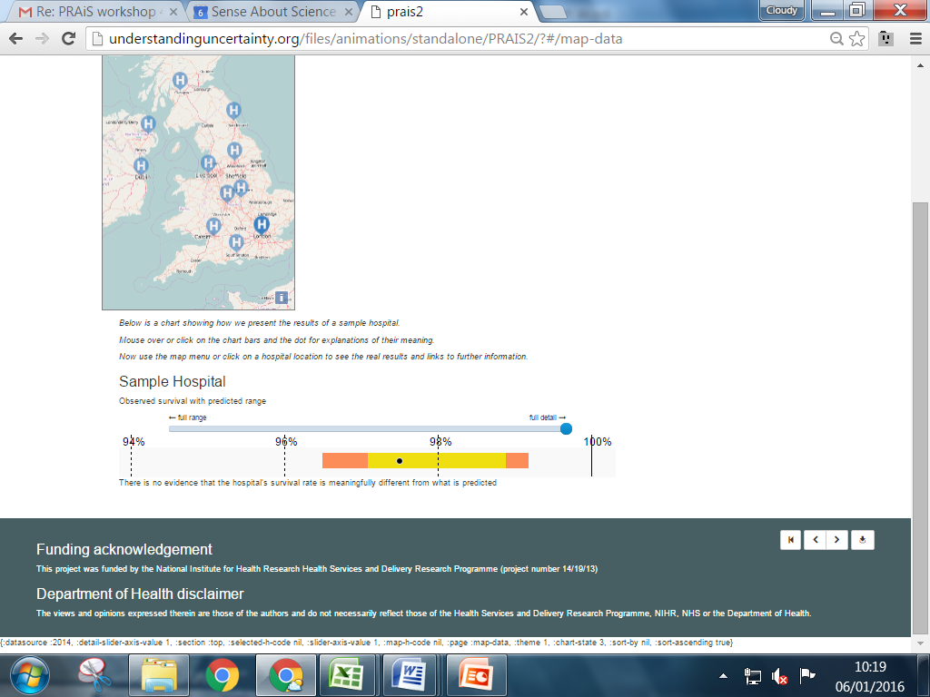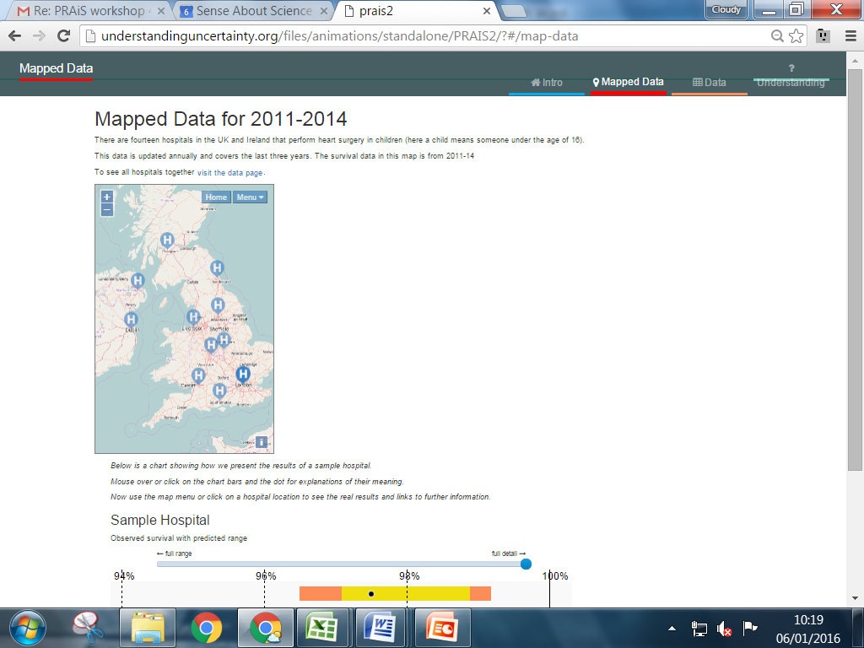**10.2. Appendix B: Mapped data tab**

**Text in image (above):**

Mapped Data for 2011-2014

There are fourteen hospitals in the UK and Ireland that perform heart surgery in children (here a child means someone under the age of 16).

This data is updated annually and covers the last three years. The survival data in this map is from 2011-14

To see all hospitals together visit the data page.

*Below is a chart showing how we present the results of a sample hospital.*

*Mouse over or click on the chart bars and the dot for explanations of their meaning.*

*Now use the map menu or click on a hospital location to see the real results and links to further information.*

### Sample Hospital

Observed survival with predicted range

*[Picture of sample data]*

There is no evidence that the hospital’s survival rate is meaningfully different from what is predicted

**10.3. Appendix C: Data tab**

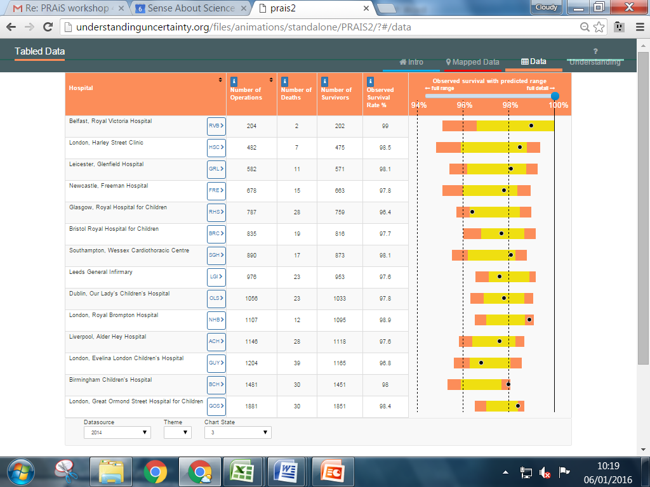

**10.4. Appendix 4: Understanding (the data)**

## 10.4.1. Background

## *Why do some children need heart surgery?*

Each year in the UK, about 7000 babies are born with a heart defect (called congenital heart disease). Congenital heart disease covers a wide range of problems from the relatively minor (such as a small hole in the heart) to more severe conditions where a child needs specialist hospital care. About half of all children born with a heart defect will need heart surgery at some stage in their childhood. Children can also develop problems with their heart as they grow up (for instance, through an infection) and also require hospital care (called acquired heart disease).

# *Where is this data from?*

[NICOR](http://www.ucl.ac.uk/nicorum/patients)(The National Institute for Cardiovascular Outcomes Research) collects data and produces analysis to enable hospitals and healthcare improvement bodies to monitor and improve the quality of care and outcomes of children who need heart surgery. Data on every surgery or intervention performed on a child for heart problems is submitted to NICOR every 3 months, and each hospital undergoes independent checks of the quality of their submitted data.

NICOR tracks the survival of these children by linking to the national register of deaths using NHS number and also from hospital records. Each year, NICOR publishes a report of survival over the previous 3 years for each hospital in the UK and Ireland. It reports the proportion of children surviving for about 40 common surgical procedures and, since 2013, also overall survival for each hospital.

If a hospital’s survival outcomes are below a certain threshold, NICOR and the hospital together examine the data and the individual cases to understand whether any further action needs to be taken. In extreme cases, a hospital might stop doing surgery while action is taken to improve the service. You can read more this process on [NICOR’s patient information pages](https://nicor4.nicor.org.uk/CHD/an_paeds.nsf/vwContent/Information%20for%20Patients?Opendocument) and in our FAQ section. In this website, we explain how survival statistics are used to support this decision making.

# *Why are survival rates monitored and published?*

In the 1990s, there were found to be problems with the standard of care for children having heart surgery at the Bristol Royal Infirmary with the proportion of children who died after surgery at Bristol being much higher than in other UK hospitals. The formal inquiry into the what happened ([The Bristol Inquiry 2001](http://webarchive.nationalarchives.gov.uk/20090811143745/http:/www.bristol-inquiry.org.uk/final_report/the_report.pdf)) led to a number of changes, including a new compulsory national reporting system so that the proportion of children surviving to 30 days after surgery for all hospitals were published every year. Results that appear unusual compared to the rest of the UK are then checked further by the national audit body (NICOR).

Until 2013, NICOR only published survival rates for certain types of procedure because there was not a good way of putting overall survival rates into context (see above). But recent [research](https://www.ucl.ac.uk/operational-research/AnalysisTools/PRAiS)has made this possible, and since 2013 NICOR has been publishing overall survival rates along with the “predicted range” for survival using the statistical model (see above). The calculation of the predicted range uses the same statistical method for all hospitals and is calculated without knowing what the survival rate at a hospital actually was.

The UK now has one of the strongest monitoring programmes in the world. Also, since reporting started, [survival rates have been improving](http://www.bbc.co.uk/news/health-32162803) and now **over 97% of children survive to at least one month after surgery.**

***Survival rate***

The percentage of operations where the child survived at least 30 days after their operation.

## 10.4.2. Understanding the predicted range

# *Why is a different survival range predicted for each hospital?*

The outcomes of surgery can vary from one hospital to another for a number of reasons. One important reason is chance factors that affect outcomes that have nothing to do with the standard of care that is offered by a hospital and cause a hospital to have more or fewer survivors than predicted from the statistical method. This does NOT mean that we have observed a genuine difference. For example, we might observe that Hospital A has more survivors than predicted this year. If this is due to chance factors, then, next year, it is just as likely that A has fewer survivors than predicted.

If a hospital’s results are inside its range then this means that the actual survival is in line with what is predicted, given the complexity and number of surgeries that the hospital performed in that time period. Comparing only to each hospital’s predicted range helps to ensure that we do not draw unjustified conclusions about small differences between observe and predicted survival or between one hospital’s survival rate and another hospital’s survival rate.

***Chance factors***

It is impossible to predict precisely what is going to happen in an individual operation. This is partly due to the inevitable inability to predict the future with certainty – all people are physically unique and will react slightly differently to medicines, anaesthetic, surgery and no heart problem is exactly the same as another. Our inability to predict precisely is also partly because there are factors that we suspect may influence the outcome but cannot be included in the statistical method either because these factors are difficult to define or no routine data on them is collected. Together, we call these all “chance factors”.

***Survival rate***

The percentage of operations where the child survived at least 30 days after their operation.

# *Why do the hospitals that do more operations have narrower ranges?*

If a hospital does not carry out many operations, then chance factors can have a large impact on their overall survival rate, and so we need to allow more leeway between observed and predicted survival in order to rule out the influence of chance factors. The ranges get narrower as the hospitals do more operations.

***Chance factors***

It is impossible to predict precisely what is going to happen in an individual operation. This is partly due to the inevitable inability to predict the future with certainty – all people are physically unique and will react slightly differently to medicines, anaesthetic, surgery and no heart problem is exactly the same as another. Our inability to predict precisely is also partly because there are factors that we suspect may influence the outcome but cannot be included in the statistical method either because these factors are difficult to define or no routine data on them is collected. Together, we call these all “chance factors”.

***Survival rate***

The percentage of operations where the child survived at least 30 days after their operation.

# *What does it mean if a hospital’s survival is outside its predicted range?*

This is a difficult question and so the answer is a bit long!

Firstly, the size of the predicted range and the position of each hospital’s dot depends on assuming that the statistical method and the data used to apply it are both perfect. They are in fact not perfect (but as good as we can currently get them) and so, in a way, the predicted range is just our best estimate of where each hospital’s survival rate would be.

So, a single hospital’s survival rate being outside its range is “unexpected”, but it *can* still be outside the white area just through chance factors.

The predicted range is calculated so that, if we are looking only at one hospital, there is a 5% (1 in 20) probability that the observed survival will be out of its predicted range just by chance (with a 1 in 40 probability of being on a particular side).

If we were looking only at one hospital, there is a 5% (1 in 20) probability that it will fall out of its range just by chance (with a 1 in 40 probability of being on a particular side).

However, if we are looking at all 14 hospitals at once there’s actually a 50% probability (10 in 20) that at least one hospital will fall outside its range just by chance! This is similar to the difference between flipping one coin and flipping many: if I only flip one coin there is a 50% probability that I’ll get one head whereas if I flipped, say, the four coins in a row the probability of me getting at least one head in the four throws goes up to 94%.

So, on average, we’d anticipate half of NICOR’s annual reports to have at least one centre outside its range, either above or below, by chance alone.

Considering now the “extended predicted range”, if we were looking only at one hospital, there is a 1 in 500 probability that it will be outside this extended range just by chance (with a 1 in 1000 probability of being on a particular side). If we are looking at all 14 hospitals at once there’s still a low probability (1 in 30) that at least one hospital will be outside the extended range just by chance.

This is why a hospital’s observed survival rate being outside the extended predicted range is considered strong evidence that the chances of a patient surviving at that hospital are different to what is expected.

***Chance factors***

It is impossible to predict precisely what is going to happen in an individual operation. This is partly due to the inevitable inability to predict the future with certainty – all people are physically unique and will react slightly differently to medicines, anaesthetic, surgery and no heart problem is exactly the same as another. Our inability to predict precisely is also partly because there are factors that we suspect may influence the outcome but cannot be included in the statistical method either because these factors are difficult to define or no routine data on them is collected. Together, we call these all “chance factors”.

***Survival rate***

The percentage of operations where the child survived at least 30 days after their operation.

# *What does the NHS do if a hospital’s survival is outside its predicted range?*

The NHS and the national audit body want to understand whether there could be a reason that can be pinpointed for a hospital to have fallen out of its range.

One reason could be that the data submitted is of poor quality. The first step undertaken by NICOR is to check whether this is the case and published results have been through a quality control process with the hospital in question to ensure, as far as possible, that this is not the case.

A further reason may be that some of the patients are unusual with more complex or rarer health problems, and that are not well accounted for by the statistical model. It could also just be due to chance factors.

The final reason NICOR considers is that there is a potential problem in the pathway of care and it is important to either rule this out or start to improve care if the national audit body decides that this is the reason. This is why the hospital and the national audit body examine the data and the hospital’s clinical processes in more detail to try see if there’s anything to worry about or if there’s something the other hospitals can learn.

If a hospital actual survival is below the predicted range, the [National Congenital Heart Disease Audit Steering Committee](https://www.ucl.ac.uk/nicor/audits/congenital/governance)is notified. The Committee in turn notifies the Medical Director and the lead doctor for congenital heart disease at that hospital and a detailed examination of the hospital’s results takes place. There are established and [published procedures](https://www.gov.uk/government/publications/detection-and-management-of-outliers-guidance-prepared-by-national-clinical-audit-advisory-group) involving the Royal College of Surgeons and/or the Care Quality Commission which can be put into action if the detailed assessment raises concerns about care.

The report on individual instances like this would then be published online by the national audit body, alongside the relevant NHCDA Annual Report.**[link to a hospital-specific report if relevant].** Such reports for previous years can be found on the NICOR publications website.

***Chance factors***

It is impossible to predict precisely what is going to happen in an individual operation. This is partly due to the inevitable inability to predict the future with certainty – all people are physically unique and will react slightly differently to medicines, anaesthetic, surgery and no heart problem is exactly the same as another. Our inability to predict precisely is also partly because there are factors that we suspect may influence the outcome but cannot be included in the statistical method either because these factors are difficult to define or no routine data on them is collected. Together, we call these all “chance factors”.

# *What is the risk adjustment method used by National Audit?*

The National Audit body uses a risk adjustment method developed by researchers at Great Ormond Street Hospital and University College London called PRAiS (Partial Risk Adjustment in Surgery). The underlying methodology of this method is published in the [academic literature](https://www.ucl.ac.uk/operational-research/AnalysisTools/PRAiS) if you are interested in learning more details.

# *Are there any limitations to risk adjustment?*

Yes there are. Risk adjustment allows for fairer comparisons to be made between hospitals but it still cannot make it completely fair. It is always ‘partial’ and there will always be important risk factors that are not routinely recorded and so cannot be captured by risk adjustment methods. Risk adjustment methods are developed on historical data (typically at least a year out of date) and cannot necessarily adjust or account for future changes to the way data is collected (for instance more complete data) or new methods of surgical or medical management.

## 10.4.3. Warnings about these results and data

# *How reliable are the data?*

The data come from the National Institute for Cardiovascular Outcomes Research (UCL NICOR) which collects national data for the National Heart Disease Audits. All hospitals performing heart surgery in children have to submit their data in a standard format to NICOR. All hospitals are independently audited each year as part of a data validation process (to check the quality of the data submitted).

So, the data are of high quality. While no large dataset is perfect (e.g., it is inevitable that a few records will not be 100% accurate), this dataset is among the most detailed and complete in the world for children’s heart surgery.

# *What are the limitations of the data?*

Apart from occasional inaccuracies in the data, there are other limits to what the data can tell us about surgery outcomes. There are risk factors not routinely collected (for instance the size or relative severity of a child’s heart defect), which means these cannot be accounted for in our statistical prediction method. Different hospitals might also record the same heart condition slightly differently and this might affect the survival percentage predicted for these hospitals.

These data are also snapshots in time of what happened at each specialist hospital. A number of particularly challenging patients one year (in ways not accounted for in our prediction) or a run of chance factors could cause a very good hospital to have worse outcomes than predicted. So we need to be careful about reading too much into any single time period.

***Chance factors***

It is impossible to predict precisely what is going to happen in an individual operation. This is partly due to the inevitable inability to predict the future with certainty – all people are physically unique and will react slightly differently to medicines, anaesthetic, surgery and no heart problem is exactly the same as another. Our inability to predict precisely is also partly because there are factors that we suspect may influence the outcome but cannot be included in the statistical method either because these factors are difficult to define or no routine data on them is collected. Together, we call these all “chance factors”.

# *What about survival after 30 days? And quality of life?*

This data set only looks at what happens shortly after surgery. These data cannot tell us about longer term (e.g. 90 day, 1 year or 5 year) survival, or other outcomes such as post-surgery complication rates or the impact of surgery on the child or their family. There is a lot of [active research](http://www.gosh.nhs.uk/medical-information/clinical-specialties/cardiothoracic-surgery-information-parents-and-visitors/research/complications-after-heart-surgery-children) going right now (due to finish around 2018) investigating how to capture, interpret and publish longer term survival and complication rates so hopefully this information will be available in the next 5 years.

Neither can it tell us about how or why a hospital achieved the recorded results, so it cannot, by itself, tell us whether one hospital offers better or worse quality care than any other. These data cannot tell you what the results are likely to be next year. It also cannot tell us anything about what happens to children who never get operated on for whatever reason, since data on these children is not currently submitted to national audit.

## 10.4.4. My family or child

# *Which hospital should I go to?*

You can use the national audit data to see how the different hospitals are doing compared to what is predicted from the statistical model for a particular time period. You can also use the national audit website to explore how many operations of each type a hospital does and survival outcomes for each of these. However, this cannot, in itself, tell you which hospital you should go to and does not provide proof that one hospital is “better” than any other, and remember that outcomes will vary from year to year through chance factors. The safety or otherwise of a hospital **cannot** be determined from survival data alone.

When considering which hospital, there are many factors to take into account, including how well the clinical team know your child and his or her medical history, any particular medical issues that your child has (for instance, some hospitals specialise in treating children with a particular problem) and how far the hospital is from your home.

You should discuss your child’s care with their specialist cardiologist to determine what the best treatment option is for your child.

***Chance factors***

It is impossible to predict precisely what is going to happen in an individual operation. This is partly due to the inevitable inability to predict the future with certainty – all people are physically unique and will react slightly differently to medicines, anaesthetic, surgery and no heart problem is exactly the same as another. Our inability to predict precisely is also partly because there are factors that we suspect may influence the outcome but cannot be included in the statistical method either because these factors are difficult to define or no routine data on them is collected. Together, we call these all “chance factors”.

# *Can the published data tell me about the risks for my child?*

No, the published data cannot tell you about the risk for your child specifically – this will depend on other factors that are not necessarily captured in the national data. Your child’s specialist cardiologist and/or cardiac surgeon will be able to discuss this with you.